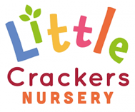 | Weekly News
30th April 2021
Joke of the week…  This little girl is feeling very sad, she only knows 25 letters of the alphabet…  She doesn’t know ‘why’!!! | It’s that time of the year again…  When I spoil the weather by asking for…  (Shhhh…. Don’t say it out loud…!)  Suncream and hats!!!  Please apply ‘all day’ sun cream to your children before they come into nursery.  If you want to send more in for a ‘top-up’ later in the day, please make sure it is labelled as we can only use the child’s own cream.  Please also send in a named sunhat that can stay in nursery.  The legionnaire designs are best as they provide face and neck protection, but anything will do!  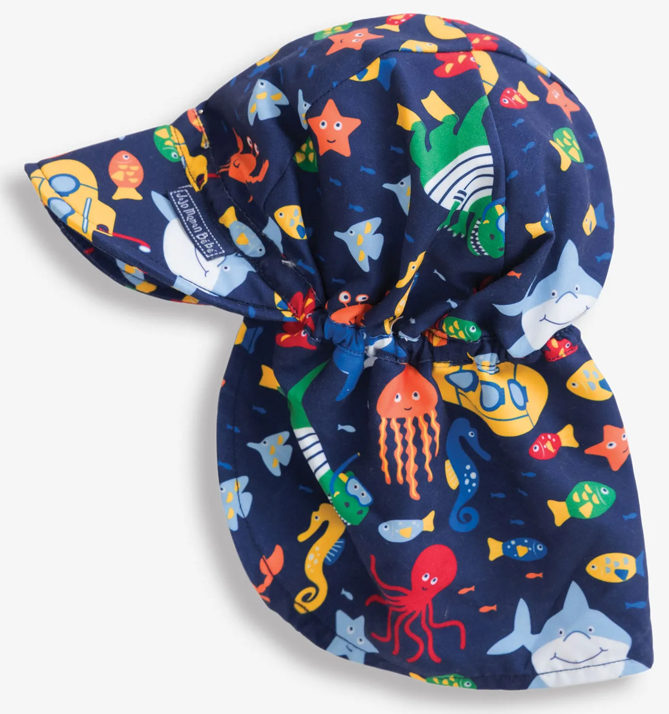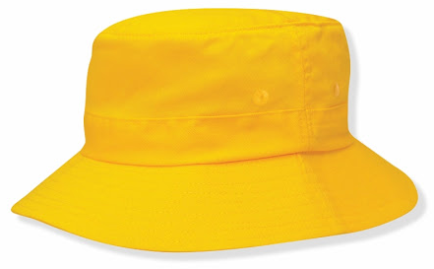
Lost property notice
We have a red and blue striped bobble hat in nursery, from Joules, similar to the one below.
If it belongs to you, please let us know, it has been siting feeling lonely for a couple of weeks now!!!
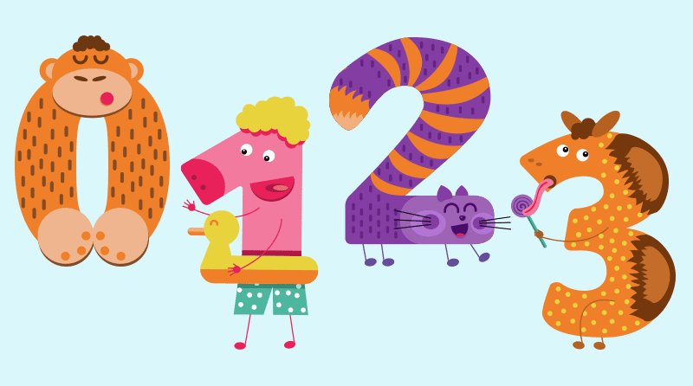  Look out for a letter about  Number Day Friday 7th May  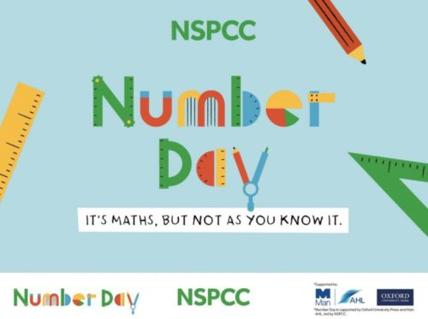 | Dates to put in your diary…  Sports Day: Monday 21st June 2021 9:30am  Pre-School Graduation: Tuesday 29th June 1:45pm  Little Crackers Timings…  Long day: 7:45-6pm Short day: 7:45-4pm  Morning: 7:45-12:45pm Afternoon 12:45-6pm  Grant sessions: 8:15-11:15 or 12:30-3:30

Little Crackers Nursery · Crackley Hall · St Joseph’s Park · Kenilworth · CV8 2FT
Telephone: 01926 514444 · Fax: 01926 514455 · e-mail: littlecrackers@crackleyhall.co.uk
www.crackleyhall.co.uk

Registered Charity Number 1087124 Company limited by guarantee Number 4177718

